NEURAL NETWORKS
Neural Network consists of interconnected computation module that simulate the behaviour of biological neuron.
Each Neural Networks consists of multiple node layers such as:
- Input Layers
- One or more hidden layers
- Output Layers

TYPES OF NEURAL NETWORK
- Multi – Layer Perceptron: A Multi-Layer Perceptron is a type of feedforward neural network that consists of an input layer, one or more hidden layers, and an output layer.
Each neuron in one layer is connected to every neuron in the next layer, and information moves only in one direction (forward).
It is mainly used for tasks like classification and regression.
Example use case: Predicting house prices or classifying emails as spam or not spam.

- Convolutional Neural Network: A Convolutional Neural Network is a deep learning model designed to automatically and adaptively learn spatial hierarchies of features through convolutional layers.
It is especially effective for image and video recognition because it captures spatial patterns like edges, textures, and objects.
Example use case: Image classification, object detection, and facial recognition.

- Recurrent Neural Network: A Recurrent Neural Network is a type of neural network designed to handle sequential data.
It has connections that loop back, allowing information to persist from one step to the next, making it suitable for time-dependent data. Example use case: Text generation, stock price prediction, and speech recognition.

- Long Short-Term Memory (LSTM): A Long Short-Term Memory network is a special type of RNN that can remember information for long periods of time.
It solves the vanishing gradient problem found in traditional RNNs by using special units called memory cells that can store and forget information selectively.
Example use case: Language translation, sentiment analysis, and music generation.

- Auto – Encoders: An Auto-Encoder is a type of neural network used to learn efficient data representations (encoding), usually for dimensionality reduction or noise removal.
It consists of an encoder (compresses data) and a decoder (reconstructs data from the compressed form). Example use case: Image denoising, anomaly detection, and data compression.

- Generative Adversarial Network: A Generative Adversarial Network consists of two neural networks — a Generator and a Discriminator — that compete with each other.
The generator creates fake data, while the discriminator tries to distinguish between real and fake data.
Through this competition, the generator learns to produce highly realistic data.
Example use case: Generating realistic images, videos, or even human faces.

PERCEPTRON
A Perceptron is the simplest type of artificial neural network — it acts like a single brain cell (neuron) that makes decisions based on input data.
It takes inputs, multiplies them by weights, adds a bias, and passes the result through an activation function to decide the output (usually 0 or 1).
It is used mainly for binary classification, i.e., deciding between two classes (like yes/no, true/false, spam/not spam).

⚙️ 2. Structure of a Perceptron
A Perceptron has four main components:
a) Inputs (x₁, x₂, x₃, …, xₙ)
These are the features or data values given to the perceptron.
Example: For predicting whether to play cricket,
- x₁ = Temperature
- x₂ = Humidity
- x₃ = Wind Speed

b) Weights (w₁, w₂, w₃, …, wₙ)
Each input has an importance or strength assigned to it — that’s called a weight.
The perceptron learns these weights during training.
Higher weight means that input is more important for the final decision.

c) Bias (b)
The bias helps to shift the decision boundary.
It allows the perceptron to make correct decisions even when all inputs are 0.
(Think of it like the “default” adjustment in the decision.)

d) Activation Function
The perceptron uses a step function as its activation function:

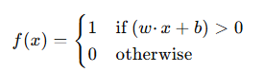
It decides whether the neuron will “fire” (output 1) or “stay silent” (output 0).

Z = W1*X1 + W2*X2 + b
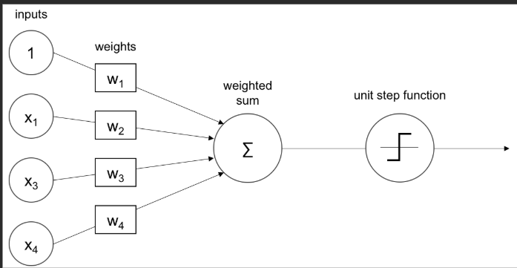
🧮 3. Working Step-by-Step
Let’s understand it with a simple example.
Example:
We want the perceptron to predict whether a student passes or fails based on:
- x₁ = Hours studied
- x₂ = Hours slept

Step 1: Assign initial weights and bias
w₁ = 0.5, w₂ = 0.4, b = -0.7

Step 2: Take input

x₁ = 2 (studied 2 hours)

x₂ = 1 (slept 1 hour)

Step 3: Calculate weighted sum

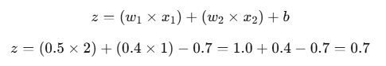

Step 4: Apply activation function
Since $z>0$, output = 1 (i.e., student passes).

STEP FUNCTION IN PERCEPTRON
The Step Function is the activation function used in the original Perceptron model.
It helps the perceptron make a binary decision — whether to “fire” (output 1) or “not fire” (output 0).
It literally takes the weighted sum of inputs and steps to 1 if the result is above a certain threshold, or steps to 0 otherwise.
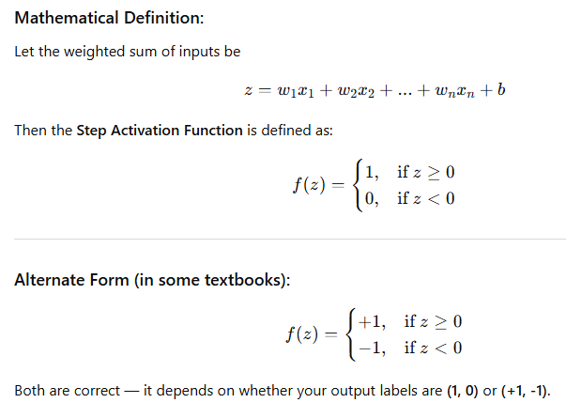

🧠 2. Intuitive Understanding
The Step Function acts like an ON/OFF switch.
- If the input sum crosses a certain boundary (the threshold), the perceptron “turns ON” (output = 1).
- If it’s below the boundary, it “turns OFF” (output = 0).
This mimics how biological neurons work — they “fire” only when the signal is strong enough.

📈 3. Graph of Step Function
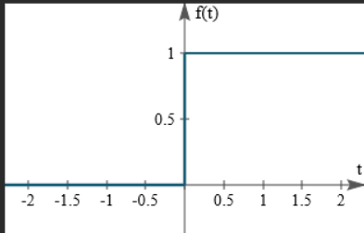

ACTIVATION FUNCTIONS
An Activation Function is a mathematical function that decides whether a neuron should be activated (fire) or not, based on the weighted sum of inputs.
In other words — it decides:
“Should this neuron pass its signal to the next layer or remain silent?”
It introduces non-linearity into the network, helping it learn complex patterns.

⚙️ 2. Role of Activation Function in a Perceptron
Let’s recall how a perceptron works:
$$z=w_{1}x_{1}+w_{2}x_{2}+...+w_{n}x_{n}+b$$
The activation function takes this sum $z$and produces an output $f(z)$:
$$\text{Output (y)}=f(z)$$
So, in the Perceptron:
- $z$is the input signal to the neuron.
- $f(z)$(activation) decides the final output (0 or 1).

🔍 3. Why Activation Function is Needed
Without an activation function, the perceptron would just be doing linear transformations — meaning:
No matter how many layers you add, the final output will still be a linear function.
That means it cannot learn complex, non-linear data (like curves, spirals, or logical XOR).
Hence, activation functions bring non-linearity, allowing neural networks to model real-world problems like:
- Speech recognition
- Image classification
- Sentiment analysis

🧩 4. Activation Function in a Simple Perceptron
In the original Perceptron (by Frank Rosenblatt, 1958), the activation function used is the Step Function.
Step Function formula:
$$f(z)=\{\begin{matrix}1, & \text{if }z≥0 \\ 0, & \text{if }z<0\end{matrix}$$
This means:
- If the weighted sum is positive, neuron outputs 1 (fires).
- If it’s negative, neuron outputs 0 (stays silent).

⚙️ 5. General Role of Activation in Deep Learning
In deep learning, the perceptron idea is extended into multi-layer neural networks (MLPs).
Here, each neuron uses an activation function to decide its output.
These functions:
- Control information flow through layers.
- Allow networks to learn complex non-linear mappings.
- Prevent outputs from becoming too large or too small.
- Make training possible via backpropagation (because most activations are differentiable).

📚 6. Types of Activation Functions
Let's see the main types, starting from the one used in Perceptron to those used in Deep Learning 👇

a) Step Function (used in Perceptron)
$$f(z)=\{\begin{matrix}1, & z≥0 \\ 0, & z<0\end{matrix}$$
🧩 Use: Binary classification (e.g., spam/not spam).
❌ Limitation: Not smooth or differentiable → can’t use gradient-based optimization.

b) Sigmoid Function
$$f(z)=\frac{1}{1+e^{-z}}$$
🧠 Smooth version of the step function.
Outputs range between 0 and 1, like a probability.
Use: Logistic regression, binary classification neural nets.
❌ Problem: Can cause vanishing gradient when z is large or small.
📈 Shape: S-shaped curve (gradual increase from 0 → 1)

c) Hyperbolic Tangent (Tanh) Function
$$f(z)=tanh⁡(z)=\frac{e^{z}-e^{-z}}{e^{z}+e^{-z}}$$
Range: (-1, 1)
It centers data around zero, making learning faster.
Use: Hidden layers in earlier neural networks.
❌ Still can have vanishing gradients for large z.
📈 Shape: S-shaped but crosses origin (0).

d) ReLU (Rectified Linear Unit)
$$f(z)=max⁡(0,z)$$
Idea: Keeps positive values as they are, sets negatives to 0.
Use: Most popular in deep learning models (CNNs, MLPs).
✅ Allows networks to learn faster and handle complex data.
❌ Problem: Some neurons may die (always output 0 if z < 0).
📈 Shape: Flat for negative z, straight line for positive z.

e) Leaky ReLU
$$f(z)=\{\begin{matrix}z, & z>0 \\ 0.01z, & z≤0\end{matrix}$$
Fixes ReLU’s “dead neuron” issue by allowing a small slope for negative z.

f) Softmax Function
$$f(z_{i})=\frac{e^{z_{i}}}{\sum_{j}{}e^{z_{j}}}$$
Used in output layer for multi-class classification (e.g., recognizing digits 0–9).
It converts raw scores into probabilities that sum to 1.

🎯 7. Summary — Why Activation Function Matters
Purpose | Explanation
Decision making | Determines whether the neuron fires or not
Non-linearity | Enables learning of complex relationships
Normalization | Keeps outputs within a manageable range
Backpropagation | Differentiable functions help update weights efficiently
Stability | Prevents exploding or vanishing outputs

🧠 8. In the Context of Perceptron vs Deep Learning
Aspect | Perceptron | Deep Neural Network
Activation used | Step Function | Sigmoid, ReLU, Tanh, etc.
Differentiability | No | Yes
Non-linearity | Limited | High
Learning method | Manual updates (rule-based) | Gradient descent (backpropagation)
Capability | Only linear problems | Linear + Non-linear problems

🧩 9. Example Visualization (conceptual)
Imagine a neuron receives input signals:
x1 → w1 \
x2 → w2 \
x3 → w3 >--- Weighted Sum (z = w·x + b) ---> Activation Function ---> Output (y)
The activation function transforms the raw signal (z) into a meaningful output for the next layer.

✅ 10. In Simple Words
Think of the activation function as the “brain” of each neuron:
- It decides whether to send the signal forward or not.
- It allows the neural network to learn from experience and understand complex patterns like images, speech, or emotions.
Without it, a deep neural network would behave just like a simple linear equation — no matter how many layers you add!

